**The Three-Schema Architecture**

The goal of the three-schema architecture, illustrated in Figure 2.2, is to separate the user applications from the physical database. In this architecture, schemas can be defined at the following three levels:

**The internal level or Physical level**

The internal level has an internal schema, which describes the physical storage structure of the database. The internal schema uses a physical data model and describes the complete details of data storage and access paths for the database.

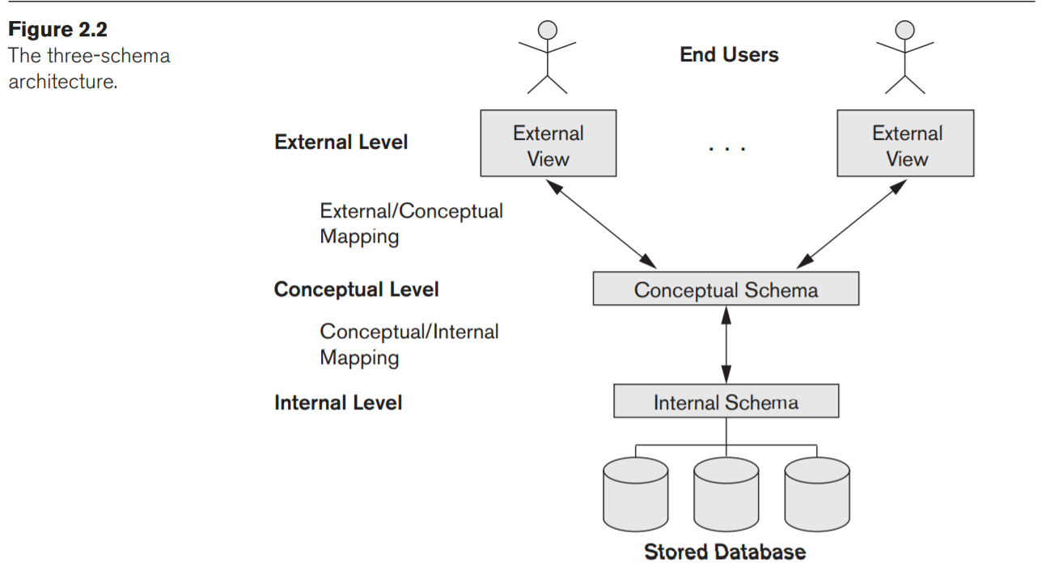

**The conceptual level**

The conceptual level has a conceptual schema, which describes the structure of the whole database for a community of users. The conceptual schema hides the details of physical storage structures and concentrates on describing entities, data types, relationships, user operations, and constraints.

**The external or view level**

The external or view level includes a number of external schemas or user views. Each external schema describes the part of the database that a particular user group is interested in and hides the rest of the database from that user group.

**Data Independence**

Data independence can be defined as the capacity to change the schema at one level of a database system without having to change the schema at the next higher level.

We can define two types of data independence:

**Physical data independence**

Physical data independence is the capacity to change the internal schema without having to change the conceptual schema. Changes to the internal schema may be needed because some physical files were reorganized for example, by creating additional access structures—to improve the performance of retrieval or update. If the same data as before remains in the database, we should not have to change the conceptual schema.

For example, providing an access path to improve retrieval speed of SECTION records (Figure 1.2) by semester and year should not require a query such as *list all sections offered in fall 2008* to be changed, although the query would be executed more efficiently by the DBMS by utilizing the new access path.

**Logical data independence**

Logical data independence is the capacity to change the conceptual schema without having to change external schemas or application programs. We may change the conceptual schema to expand the database (by adding a record type or data item), to change constraints, or to reduce the database (by removing a record type or data item). In the last case, external schemas that refer only to the remaining data should not be affected.

For example, the external schema of Figure 1.5(a) should not be affected by changing the GRADE_REPORT file (or record type) shown in Figure 1.2 into the one shown in Figure 1.6(a). Only the view definition and the mappings need to be changed in a DBMS that supports logical data independence. Changes to constraints can be applied to the conceptual schema without affecting the external schemas or application programs.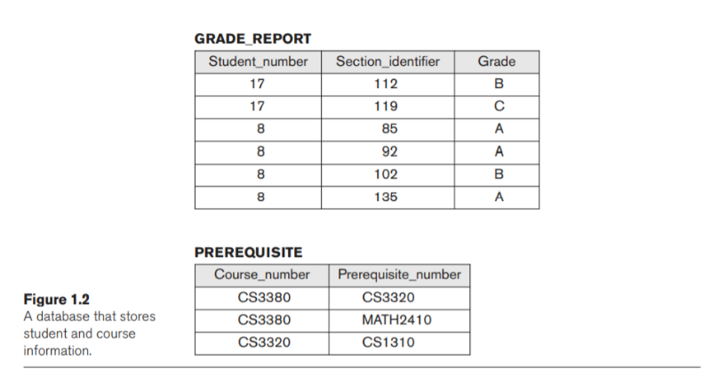

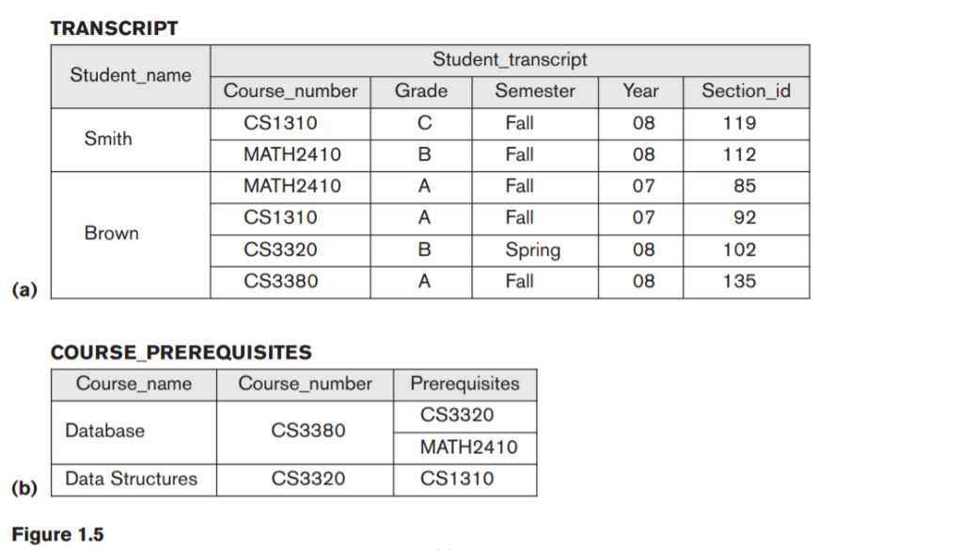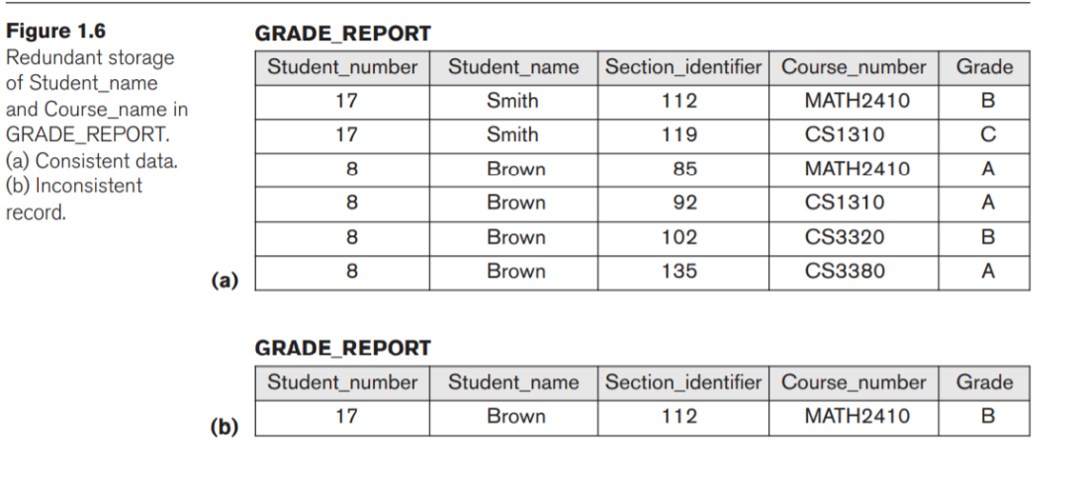

Generally, physical data independence exists in most databases and file environments where physical details, such as the exact location of data on disk, and hardware details of storage encoding, placement, compression, splitting, merging of records, and so on are hidden from the user. Applications remain unaware of these details. On the other hand, logical data independence is harder to achieve because it allows structural and constraint changes without affecting application programs.